

MEET Y1 - Unit 2 - Lab Part 1

Intro to Data Types

In this lab, you will learn about different data types, including int, float, str, and bool, and how to use type() to determine what data type something is using Python in IDLE3.

Follow these instructions:
0. In Google Docs, at the top left of your screen, click File > Download as > Microsoft Word … so that you can edit this lab document.

1. Fill in column 2 of the table on the next page by writing what you would expect the output from Python to be. If you don't think Python can do something, write error. For example, if you did the first row, it would be like this:
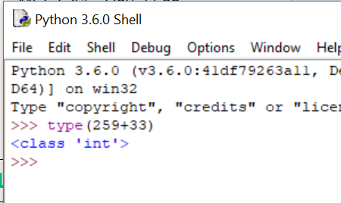

Column 1 | Column 2 | Column 3
Expression | Your Guess | IDLE3 Output
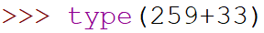 | integer | int
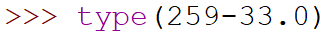
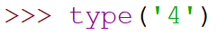
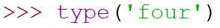
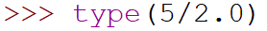
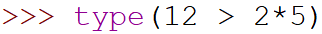
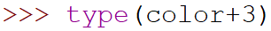
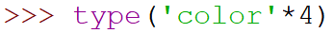

2. Open IDLE3 

3. In the Python shell, type the code from column 1 in each row, hit enter and write what the output is in column 3. Does it match what you thought the output would be?

Lab 1 bonus:
1. Think about why you got the errors with some lines. How can you change the line to get no error? Test your guess in the Python shell!

2. Now type all of the lines again without the word “type” at the beginning. What do you get?

3. If you have extra time, work on Unit 1 lab from yesterday or create your own design using turtle!

